Version 1.0 – Prey Vs Predator Genetic Algorithm

**Using this application**

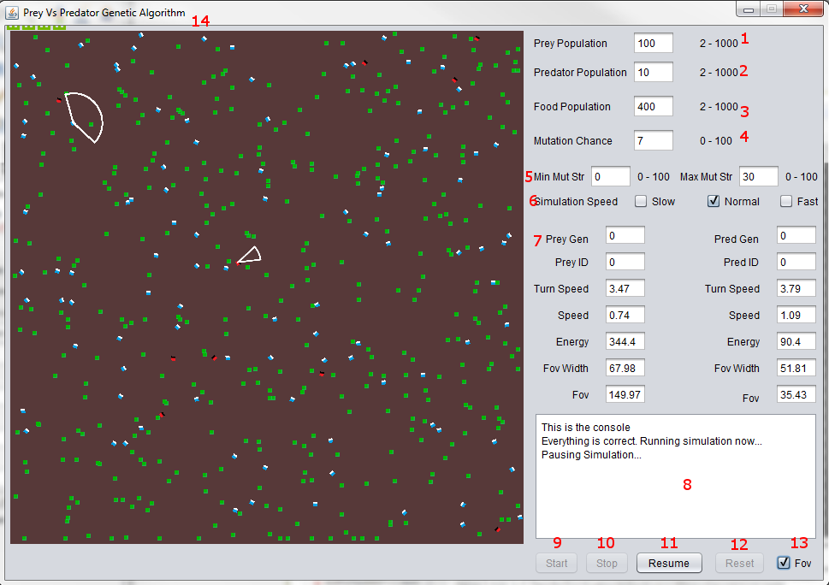

|  |  |
| --- | --- |
| **1** | Controls the population of the Prey agents (Blue blocks) |
| **2** | Controls the population of the Predator agents (Red blocks) |
| **3** | Controls the amount of food on screen (Green blocks) |
| **4** | Controls the chance that an attribute will mutate |
| **5** | Min and Max mutation strength range. Controls how strong the mutation is. Min has to be lower than Max. |
| **6** | Controls the speed of the simulation. |
| **7** | 7 displays the attributes of the chosen individuals |
| **8** | 8 Console to relay feedback to the user. |
| **9** | Starts the simulation when 1,2, 3,4 and 5 have correct values |
| **10** | Stops the simulation so user can select individuals by clicking them in the window |
| **11** | Resumes the simulation. |
| **12** | Resets the whole application |
| **13** | Controls where the field of views for the selected individuals is visible |
| **14** | Simulation window. Green is grassfood, red is predator, blue is prey. |

**What is it?**

An application that improves the attributes of prey and predator agents through a genetic algorithm.

**How does it work?**

Each agent has 4 attributes and those are Speed, Turn Speed, Field of View angle and Field of View Length. These attributes are changed through the genetic algorithm.

**What is a genetic algorithm?**

A genetic algorithm is a process where a population of individuals are subjected to ***evaluation***, ***crossover*** and ***mutation***.

**Evaluation** -> All individuals are given a fitness value based on their performance. Generally the fitter individual will have higher than average attributes and has obtained the most energy. (an agent obtains more energy by eating its target).

**Crossover** -> Initially two individuals are selected and out of the two whoever has the highest fitness value is chosen to create offspring. (aka Tournament selection). When two winners are chosen their chromosome (the 4 attributes) are merged with a crossover point to create a new offspring.

Chromosome 1:

1st 2nd 3rd 4th

0 1 0 1

Chromosome 2:

1 1 0 0

Crossover point of 2nd will result in Offspring 1 looking like this:

0 1 0 0

The first 2 points are made up of the 1st chromosome while the other two are made up of the 2nd chromosome.

**Mutation** -> For a very simply case like the one above it is as simple as flipping one of the numbers to the opposite value. Another method would be to swap indexes. With this application the attributes are made up of varying values so flipping or swapping is not applicable. The solution to this is to increase the attribute by a small value from a range.

Finally the new generation offspring replaces the old generation and the cycle continues.

**What are the conditions for creating the next generation?**

When either all the prey or all the predators have died.